Calculate the depth of sequencing:

Human transcriptome: 10^8 bp

*C. parvum* transcriptome: about 8\*10^6 bp (*C. parvum* genome is 9.1 Mb, all extron, so I assume the transcriptome is similar size as the genome)

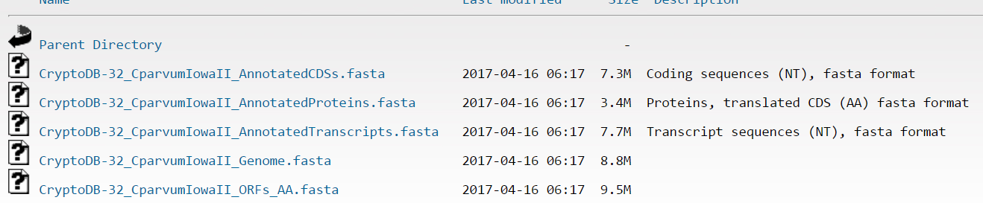

For 4Gb data, it will give human transcripts about 40X, for *C. parvum*, the coverage= (4\*10^9)/(500\*8\*10^6)=1. So it gives *C. parvum* 1X coverage.

If we need 10X coverage for *C. parvum* transcripts, we probably need 40Gb.